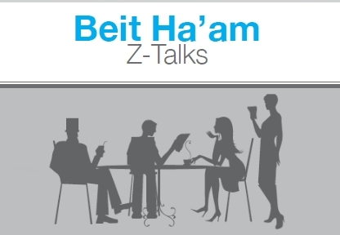
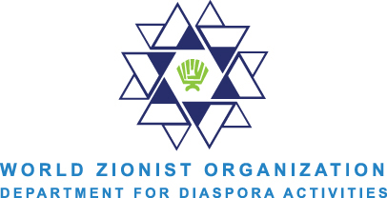

Defining and Redefining Zionism Workshop
Aliya Fastman

Why is a workshop on the definition of Zionism needed?
Increasingly the word Zionism and the ideology that underpins it, has come under attack. More and more, Zionism is equated with racism, oppression, and exclusion. The battle to rectify these impressions should be attempted at both a macro and micro level. The macro level refers to governmental and institutional dialogue but the micro level should be pursued vis-a-vie the small group format. This is the strategy that BDS as well as several other anti-Zionist organizations have utilized with great success. This means, essentially, setting up talks and workshops at a local level in every small organization that one has the ability to identify, and sending representatives and facilitators to lead organized and directed discussions on the true meaning of Zionism as a politically healthy and affirming ideology. This means we must reach out beyond the choir to connect with student and campus groups, local synagogues, churches, and environmental and cultural organizations.

Goals:
-To begin the process of strengthening and rehabilitating the image of Zionism.
-To work on reducing the negative connotations of the word Zionism itself.
-To empower people to have educated conversations about Zionism.
-To target potential friends of Israel and strengthen relationships based on mutual values and beliefs.

Proposal:
To hold individualized salons discussing the textbook meaning of Zionism, how it has evolved over history, and how it is seen today. These discussions will be aimed at increasing the knowledge of participants through informed, directed conversations and dialogues.

What this will look like:
Several templates will be needed depending on the audience that the facilitator will be working with. One will have to be prepared for wide-ranging potential scenarios and responses. For more responsive Pro-Israel settings, one can focus on the participant’s own connections to Israel as the Jewish homeland, and what it means to have a connection in the diaspora. For audiences that are either primarily not Jewish, or less receptive to Zionism as the Jewish self-determination, one will need to focus on the historical legitimacy of Zionism and how it has changed and evolved over the years. The key is to be flexible, well educated, and receptive to hearing different narratives.

How to begin a workshop:
1. Ask people what the first word that comes to mind is when hearing the word Zionism. This will not only help gauge what sort of group one is working with, but also help people engage in deeper thinking on what Zionism is and why they may have uneasiness towards the word itself.
2. Talk about the textbook and initial definition of Zionism and the history of it, i.e. the political manifestation of a need for a Jewish homeland.
3. As the facilitator, one has to be well informed of the current politics as well as the history. If people bring up current events, be ready to discuss the facts on the ground. Often, if people are impassioned and see things as injustices right now, they don’t care about history.

Desired number of attendees: This format is flexible and can accommodate a small or large group of people. Ideally, with a larger group of people, there would be more than one facilitator and the larger group would be broken up into smaller discussion groups with a trained facilitator leading each one. In order to have a deeper conversation about the topic, 6-20 participants is recommended per group.

Proposed location: Workshops can be held at the building or meeting space of the group that one is working with. It’s also a possibility to rent out a room in order to have a community-wide event.
Length of Workshop: 1.5-2.5 hours
Suggested Fee: Free
Materials Needed: A Zionism 101 page or WZO handouts for people to take if desired. A sign-up sheet for people to join our mailing list if interested in being involved in more WZO seminars and events.
How to Advertise:
-Get the word out with Jewish organizations, student groups and synagogues.
-Put flyers on campus.
-Send personal emails to specific groups that may be interested in this workshop.

